GUIDELINES & TOOLS FOR GOVERNANCE REPRESENTATIVES

ALL MEMBERS, VOTING & NON-VOTING
- Familiarize themselves with the mission of the committee as indicated on the Blue List, and GCC's mission statement.
- Regularly attend meetings and assign a proxy in the event of absence.
- Know who appointed them and know when their term ends (indicated on the Blue List).
- Consult with their appointing agency (Guild, Senate, and CSEA executives, ASGCC cabinet, Administration) for general guidance, and for specific concerns about policy proposals.
- Provide a report to their constituent leadership after each meeting using the online form or by email.
- In the event of a disagreement about governance procedures, consult Administrative Regulation (AR) 2511, the Governance Document, or contact the Governance Review Committee.
- When first participating in governance committees, get acquainted with the resources available: minutes, Governance Update, the governance webpage.

TERMS OF APPOINTMENTS FOR VOTING SEATS
2-year appointment: “CSEA” seats
4-year appointment: Academic “Senate” seats; “Guild” seats; “Joint” faculty seats
4-year appointment: “Administration” and “Manager/Confidential” seats

Some committee chair and seats are ex officio or are tied to released time (AR 2511).
Please note that positions in the following categories do not have a term of service: “ASGCC” (changes each semester), “Minutes Recorder” and “Resource.” “Division Chairs” may have a term where applicable.

RESOURCE MEMBERS NON-VOTING
Persons may be appointed to a committee, by the committee, to serve as resources of information; however, a resource member will not have voting rights. A resource can be any person a committee feels has expertise to offer with respect to the committee’s business (AR 2511).

TOOLS & RESOURCES
These documents and other links are available on the governance page in SharePoint
- AR 2511 Governance Document, especially the “Meeting Procedures” section
- Blue List
- Links to the committee report for faculty and staff
- Proxy Form

ROUTINES FOR CHAIRPERSONS OF A COMMITTEE
BEFORE A MEETING
- Send a meeting notification, or call for agenda items 2 weeks to 1 week in advance of a scheduled meeting.
- Adhere to a regular meeting date and time (according to the Blue List). And consistent Zoom link if applicable.
- Verify that membership matches the Blue List.
- Comply with the Meeting Procedures section and other information in AR 2511, the Governance Document.
- Forward the agenda to the committee four working days before the meeting; include the student government through email asvpad@glendale.edu
- Agenda and Minutes should be in Board Docs for public access and committee members

ROUTINES FOR CHAIRPERSONS OF A COMMITTEE continued

DURING A MEETING
- Verify that the committee has a quorum before action is taken. Discussion may take place in the absence of a quorum but no actions or motions can be taken without a quorum.
- How to determine quorum. It is 50% + 1 of voting members. Example: for committees with and odd or even number you may round up or down. Just use the same consistent manner to determine quorum.
- Verify that only voting members vote; “Resource” members do not have a vote. Include the current copy of committee membership (Blue List).
- Remain impartial; avoid taking sides in order to conduct a meeting fairly and consistently.
- During the meeting – help the minutes recorder by repeating who moved and seconded the motion.

DURING HYFLEX/REMOTE MEETINGS

- At the beginning of the meeting/term, inform/remind attendees of the meeting protocol/procedure.
- Be consistent and clear on how discussion will occur, how a vote is taken; raise hand to get in the que, etc. The protocol should be consistent and clear throughout the meeting/term.
- Voting: When calling for a vote, be clear on how the vote should be cast.

AFTER A MEETING
- Shepherd items to the appropriate Standing Committee if a stakeholder does not assume ownership.
- In minutes, abbreviations should be spelled out. For example, introduce the topic “Student Learning Outcomes (SLO)” and then abbreviate thereafter. Titles to board policies and administrative regulations should follow the number; for example,
“Administrative Regulation (AR) 2511: Governance Document.”
- Each month produce a “Motions Report” along with minutes; send these documents to the appropriate Standing Committee and cc the Governance office.
- Upload minutes in Board Docs: We accept un-adopted minutes in order to keep information flowing.
- Review the monthly Governance Update report: Is the information correct?
- For any frequently absent members, do the following:
  - Contact the absentee.
  - Encourage assigning a proxy.
  - Notify the Governance Office once #1 and #2 have been exhausted.

MINUTES Requirements (Admin. Reg. 2511: Governance Document)
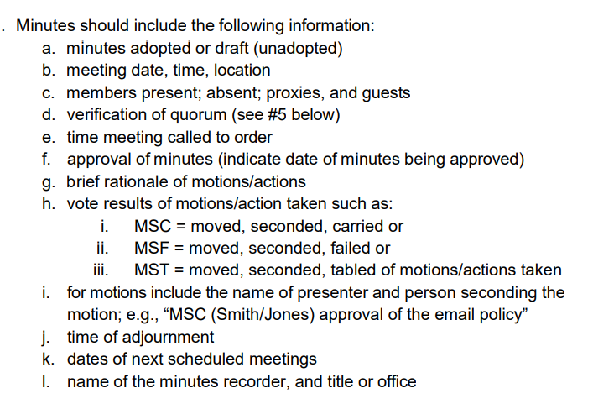

Got questions on governance? Contact Frankie Strong fstrong@glendale.edu, ext. 5393
Governance webpage www.glendale.edu/governance
Administrative Regulation 2511, Governance Document

