Resistance Training Guidelines for different goals
Erin Calderone
adapted from Brown, Lee and NSCA Strength Training, 2nd Edition Champaign, IL: Human Kinetics, 2017
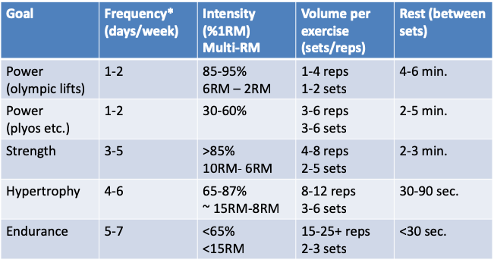

Begin with 1-2 sets of 1 exercise for each muscle group.
Work up to 3-4 sets of each exercise, and or add more exercises.
Muscles of the same muscle group need a minimum of 48 hours rest between workouts; workouts for the same muscle group must be performed on non-consecutive days of the week.

Progression (2-for-2 Rule): If you can perform 2 additional reps on 2 separate training sessions, increase the load (5-10%)

